

Release Date: Winter
Genre: Zombie Paradise Action
Platform: Wii
Rating: TBC
Developer: Capcom®
Price: TBC

Game Description:
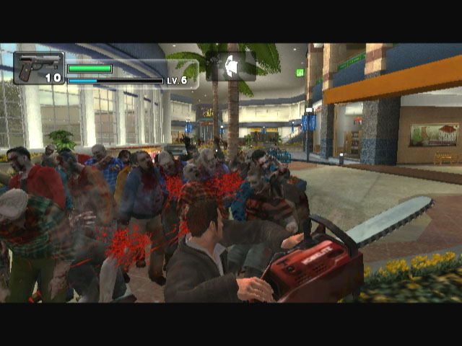
Based on the critically acclaimed Dead Rising™ for the Xbox 360™ video game and entertainment system from Microsoft, Dead Rising: Chop Till You Drop follows the harrowing tale of Frank West, an overly zealous freelance journalist on a hunt for the scoop of a lifetime. In pursuit of a juicy lead, he makes his way to the small suburban town of Willamette only to find that it has become overrun by zombies. Frank escapes to the local shopping mall where he thinks he will find safety only to discover its crawling with the un-dead. In order to survive players will have full reign of a realistic shopping centre where an endless supply of real and makeshift weapons will be at their disposal to fight off the flesh-hungry mob. Utilising the Wii remote, this new iteration to the series will take zombie-bashing to a new level as you shake, swing and aim your weapons in an effort to take the enemies down.

The game is split into a series of individual cases, all of which Frank must complete in order to gain vital information that allows him to piece together the truth behind the horrendous epidemic.
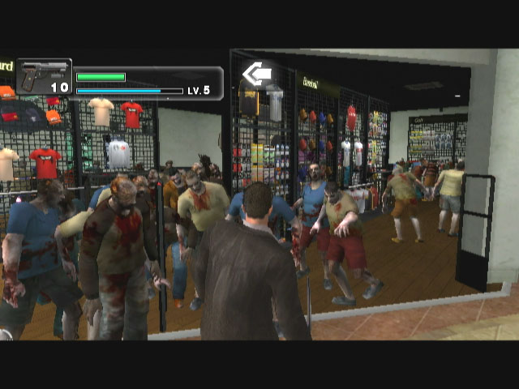
Players will be faced with the dilemma of deciding the rescue priority of the Willamette residents who have also sought sanctuary in the mall. Depending on the player’s skill some may not be as fortunate as others as each rescue needs to be undertaken in a set time period causing players to delay completion of a case in order to save a fellow human. Dead Rising: Chop Till You Drop’s infectious humour delivers welcome relief from the incessant tide of zombies with players able to dress Frank up in a variety of comedic costumes and take on the undead hordes with a selection of highly ineffective weapons such as a toy sword or a football.

Features:

- Utilises the same engine as Resident Evil 4 Wii edition
- New level of interaction utilizing the Wii remote – aim and fire guns, swing and throw weapons and shake off zombie attacks with added Wii remote functionality
- New enemies exclusive to Dead Rising: Chop Till You Drop
- Huge environment – Vast indoor and outdoor mall areas provide a variety of different locations to explore
- Improved save functionality allows for more seamless gameplay
- Hordes of enemies on screen at once resulting in non-stop, pulse pounding action
- Anything in the mall is at Frank’s disposal for battling the flesh-hungry mob
  - Grab environmental objects, such as umbrellas and benches, or store items, such as golf clubs and lawnmowers from the mall shops to use as improvised weapons
  - Consume food and drink from one of the malls many restaurants and cafés to resume Frank’s health

